
Sukkur IBA University
Department of Computer Science
Applied Physics

Lab # 04: Parallel circuit

Instructor: Engr: Asif Ali

Note: Submit this lab hand-out in the next lab with attached solved activities and exercises

Submission Profile
Name: Submission date:
Enrolment ID: Receiving authority name and signature:
Comments:
________________________________________________________________________________
Instructor Signature
Objectives:
- To get hands on practice to design & analyse the linear circuits on NI Elvis-II.
- The objective of this experiment is to determine the equivalent resistance parallel circuit and also find the current across different resistors in the parallel circuit.
- You will apply various voltages across the resistor (or circuit) using a power supply and measure the current I through the resistor and the voltage V across the resistor for each setting of the power supply. From a plot of V vs. I, you will determine the resistance.
- You will compare the measured value of the resistance with the manufacturer's value.
Lab Hardware and Software Required:
- NI Elvis-II Kit
- Resistors
- Connecting wires
- PC
- Multisim

Background Theory:
Combinations of Resistors
Resistors can be combined in simple circuit arrangements that increase or decrease the over- all resistance in the circuit. These arrangements are called series and parallel circuits. Following Fig. shows the resistors in a parallel arrangement.
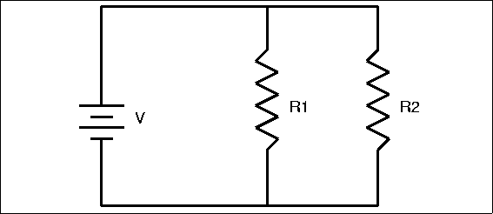
Figure 1
In order to charges move in a conductor, there must be a potential difference across the conductor, and there must be a complete path leading away from and back to the source of emf. In the parallel arrangement shown in Figure 1. the current divides at the junction A and recombines at junction B. Therefore, the current through R1 and R2 will be different. Notice that in this case ΔV = ΔV1= ΔV2: That is, the potential drop across each resistor is the same. Using algebra, the relationships for determining equivalent resistance Req for parallel can be derived. Parallel
1/Req = 1/R1 + 1/R2 + ……. 1/Rn
The reciprocal of the equivalent resistance is the sum of the reciprocals of the individual resistances.

Lab Activities:
Solve the below series circuit. To find unknown quantities as mentioned in worksheet. Choose the values of resistors of your own choice
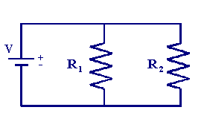
Figure 2

Table 1
Resistor | Band 1 |  | Band 2 |  | Band 3 |  | Resistance | Band 4
Resistor | Color | Value | Color | Value | Color | Value | $$Ω$$ | Color | Tolerance %
1
2

Procedure: Determining Equivalent Resistance-Series Arrangement
- Connect the two resistors in a parallel arrangement.
- Supply 5V to the circuit
- Find the values of four resistors
- Find the voltage and current across R1 and R2
Worksheet
Table-2
Resistors | R1 | R2
R (Nominal)
R (Actual)

Table-3
Values | V | I1 | I2
Measured
Calculated

Lab Exercise

1. Solve the following circuits and attach solve results on A4 page, MultiSim result and also Elvis Kit result.
Task-01
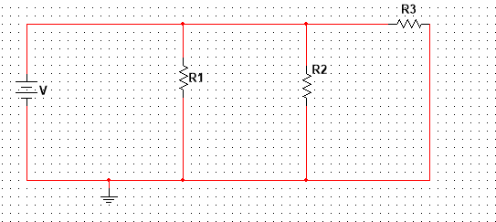

Resistor | Band 1 |  | Band 2 |  | Band 3 |  | Resistance | Band 4
Resistor | Color | Value | Color | Value | Color | Value | $$Ω$$ | Color | Tolerance %
1
2
3

Procedure: Determining Equivalent Resistance-Series Arrangement
- Connect the two resistors in a parallel arrangement.
- Supply 5V to the circuit
- Find the values of four resistors
- Find the voltage and current across R1, R2, and R3
Worksheet
Table-2
Resistors | R1 | R2 | R3
R (Nominal)
R (Actual)

Table-3
Values | V | I1 | I2 | I3
Measured
Calculated

2. Solve the following circuits and attach solve results on A4 page, MultiSim result and also Elvis Kit result.
Task-02
